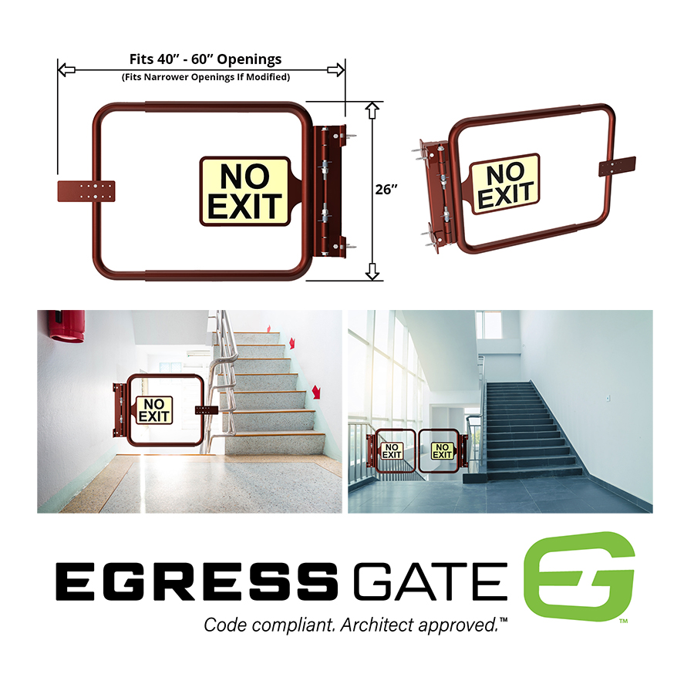

SECTION 05 52 16

METAL EGRESS GATES

This section includes editing notes to assist the user in editing the section to suit project requirements. These notes are included as hidden text, and can be revealed or hidden by the following method in Microsoft Word:

Display the FILE tab on the ribbon, click OPTIONS, then DISPLAY. Select or deselect HIDDEN TEXT.

- GENERAL

  - SUMMARY

    - Section Includes:
      - Prefabricated egress gates for stairwells.

    - Related Sections:
      - Division 01: Administrative, procedural, and temporary work requirements.

      - Section [28 46 00 - Fire Detection and Alarm] [__ __ __ - ________]: Electromagnetic hold-open devices for gates.

  - REFERENCES

    - American Welding Society (AWS) D1.1/D1.1M - Structural Welding Code - Steel.

    - ASTM International (ASTM):
      - A36/A36M - Standard Specification for Carbon Structural Steel.
      - E2072 - Standard Specification for Photoluminescent (Phosphorescent) Safety Markings.

    - International Code Council (ICC):
      - International Building Code (IBC).
      - International Fire Code (IFC).

    - National Fire Protection Association (NFPA) 101 - Life Safety Code.

    - Underwriters Laboratories, Inc. (UL) 1994 - Standard for Luminous Egress Path Marking Systems.

    - United States Department of Justice (USDOJ) - ADA Standards for Accessible Design (SAD).

  - SUBMITTALS

    - Action Submittals:
      - Product Data: Manufacturer’s descriptive data including dimensions, materials, finishes, and mounting details.

    - Informational Submittals:
      - Certificates of Compliance: Show product compliance with reference standards.

    - Closeout Submittals:
      - Maintenance Data: Include recommendations for sign cleaning and routine maintenance.

  - QUALITY ASSURANCE

    - Installer Qualifications: Minimum [2] [__] years experience in work of this Section.

    - Provide “No Exit” signs in accordance with [NFPA 101.] [ICC IBC.] [ICC IFC.] [____.]

  - DELIVERY, STORAGE AND HANDLING

    - Store signs in cool, dry location in original packaging until installed.

    - Store gates above ground on platforms, skids, or other supports; separate with wooden separators.

    - Protect steel from corrosion.

    - Prevent damage to prime coat.

- PRODUCTS

  - MANUFACTURERS

    - Contract Documents are based on products by EgressGate www.eggressgate.com.

    - Substitutions: [Under provisions of Division 01.] [Not permitted.]

  - MATERIALS

    - Steel Shapes, Tube, Pipe, and Plate: ASTM A36/A36M.

    - Hinges: Self-closing type, single acting, of sufficient spring power to completely close gate without excessive noise upon impacting strike plate.

    - Photoluminescent Sign Luminance Properties: ASTM E2072 and UL 1994.
      - From test sample activation: 10.76 lx (1.000 fc) for 60.0 minutes:
        - For 10 minutes after lights go out: Minimum 30 mcd per square meter.
        - For 60 minutes after lights go out: Minimum 7 mcd per square meter.
        - For 90 minutes after light go out: Minimum 5 mcd per square meter.

  - MANUFACTURED UNITS

    - Metal Egress Gates:
      - Comply with requirements of IBC and NFPA 101.
      - Provide barrier in stairwells to prevent accidental travel beyond designated exit level.
      - 90 to 180 degree opening.
      - Self-closing and self-stopping.
      - Reversible swing direction.
      - Universal mounting.
      - Width: Adjustable to fit openings from 40 to 60 inches.
      - For wide openings or to avoid obstructions, utilize two egress gates for a double swing gate.
      - Height: 32 inches.

    - “No Exit” Signs:
      - Description: Non-flexible photoluminescent sign with tactile raised numbers and Braille markings.
      - Listed to UL 1994.
      - Size: 12 x 9 inches.
      - Conform to [USDOJ SAD] [applicable accessibility code] [____] for sign design and content.

  - FABRICATION

    - Shop assemble gates, ready for delivery to site.

    - Fabricate with joints tightly fitted and secured.

    - Welding to conform to AWS D1.1/D1.1M. Grind exposed welds smooth.

    - Ease exposed edges to small uniform radius.

    - Equip each gate with:
      - Universal mounting.
      - Two hinges.
      - Steel stop plate welded to gate, with slotted bolt holes for adjustment.
      - Steel sign plate with photoluminescent “No Exit” sign welded to gate.

  - FINISHES

    - Ferrous Metal: Shop painted with one coat red oxide primer paint.

- EXECUTION

  - INSTALLATION

    - Install gates in accordance with manufacturer’s instructions.

    - Weld anchor plates to mounting bars if required based on adjacent construction.

    - Weld stop plate to gates.

    - Extend gates to required width, then weld expansion joints on top and bottom tubes.

    - Welding to conform to AWS D1.1/D1.1M. Grind welds smooth.

  - ADJUSTING

    - Clean and touch up damaged primer paint with same product as applied in shop.

END OF SECTION
ILLUSTRATIONS

WALL-MOUNT SWING GATE

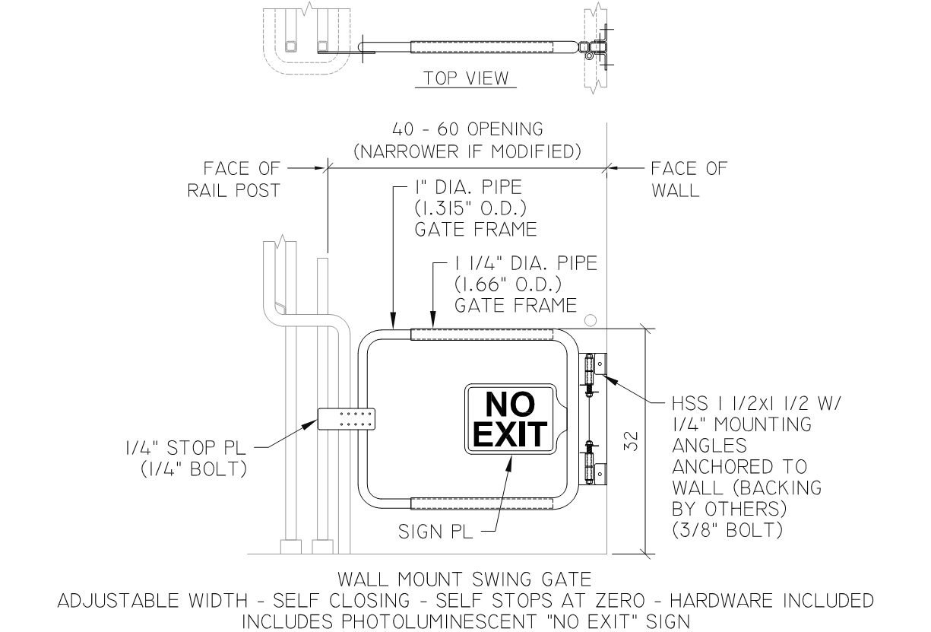

POST-MOUNTED SWING GATE

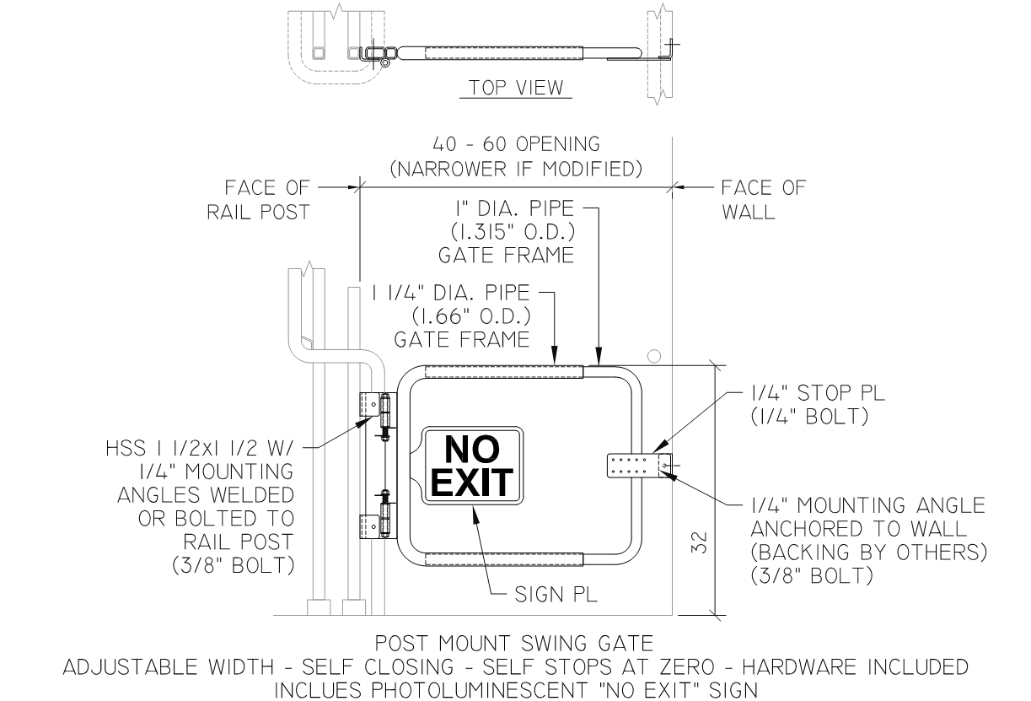

DOUBLE SWING GATE

